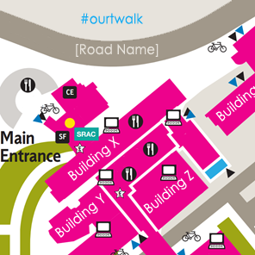
[Our] Twalk
[Day] [Date] [Time and duration]
The aim of the walk is to experience a different conversational space around a set of landmarks. The walk will last one hour.
Together, we will walk, talk and post thoughts and pictures to Twitter. The #Twalk will happen at [whatever] University, but it will also happen on other university campuses at the same time. Even though we are in different locations, we will follow the same twalk questions and we will visit equivalent places.

Our twalk will be led by [our leader’s name] – include a photo, especially if some participants have not met the person].
We will [where we will go, what we will do, and why this is a good thing to do. Something about the topic we will discuss.]
Viewpoints – ‘pause places’ where we can have discussions relating to our theme. Each Viewpoint creates an opportunity to discuss a new topic inspired by our current location. [The walk leader] will pose the new topic and in small groups we will discuss the question or topic, snap a picture of the ‘landmark’, tweet our picture and response, and continue walking and talking. As we continue we will see how others are responding and reply to them.
Don’t stay long at a Viewpoint – long enough to ask the question and begin your small group discussions. But move on!
People will take photographs, and discuss the topic as they walk in pairs to the next Viewpoint. Don’t forget to Tweet!
There are 5 places, 5 Topics, just 1 hour.

Itinerary: Places to Visit and Viewpoint Topics
Time | Room# or Name | Topics - Discuss, photograph and tweet on the following topics
[12:55] | Meet at the [meeting place] | Are you ready? Tweet group selfies and say “Hi” [#ourtwalk]
[13:00] | [Name or room number of location 1]  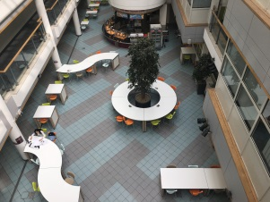 | T1 [pose your question or discussion topic here]  For Topic 1 (T1), answer: A1 [#ourtwalk] [your answer…]
[13:10] | [Name or room number of location 2]  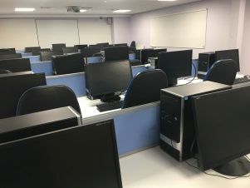 | T2 [pose your question or discussion topic here]  For Topic 2 (T1), answer: A2 [#ourtwalk] [your answer…]
[13:20] | [Name or room number of location 3]  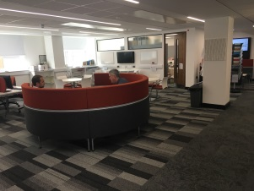 | T3 [pose your question or discussion topic here]  For Topic 3 (T1), answer: A3 [#ourtwalk] [your answer…]
[13:40] | [Name or room number of location 4]  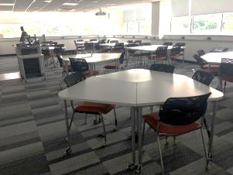 | T4 [pose your question or discussion topic here]  For To  pic 4 (T1), answer: A4 [#ourtwalk] [your answer…]
[13:50] | [Name or room number of location 5]  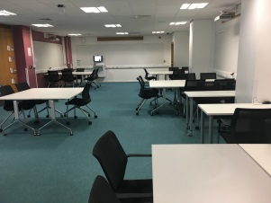 | T5 [pose your question or discussion topic here]  For Topic 5 (T1), answer: A2 [#ourtwalk] [your answer…]
[14:00] | End | Wave Goodbye! Final thoughts to [#ourtwalk]

